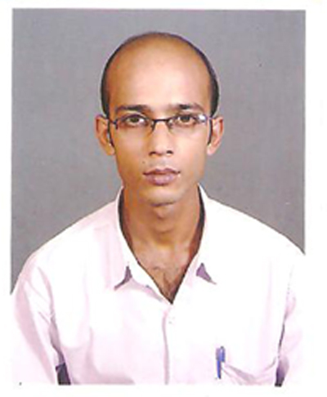
CURRICULUM VITAE

NAME : BISWAJIT GHOSH

DATE OF BIRTH : 12th January, 1981

FATHER’S NAME : Late BISWANATH GHOSH

ADDRESS FOR CORRESPONDENCE

PRESENT ADDRESS &
PERMANENT ADDRESS : BISWAJIT GHOSH
82 NEW TOLLYGUNG
KOLKATA-93,

MARITAL STATUS : SINGLE

CONTACT NUMBER : 9831519256,9831432159
(R) 03212-283043
E-mail : biswajjitghosh@yahoo.com
: oslina256@yahoo.co.in

EDUCATIONAL QUALIFICATION

1 UNDER GRADUATE FROM (N. S. O.U)

PROFESSIONAL QUALIFICATION:

:: COMPUTER ::

COURSE NAME : ALPHA MAYA

FROM : MAYA ACADEMY OF ADVANCED
CINEMATICS (MAAC)
( A DIVISION OF MAYA
ENTERTAINMENT LIMITED)

SOFTWARE KNOWN

OPERATING SYSTEM : WINDOS 2000, XP

APPLICATIONSOFTWARE : MS-WORD, PHOTOSHOP CS,
AFTER EFFECTS6.5,
PREMIERE PRO2, 3Ds MAX8,
CHARACTER STUDIO, DEEP PAINT3D,
COOL EDIT PRO,

CONCEPT : VIDEO EDITING, COMPOSTING,

DATE:

PLACE: …………………………..
SIGNATURE

